**COAST GUARD CARE ANYWHERE SELF-PACED TRAINING**

**COURSE GUIDE**

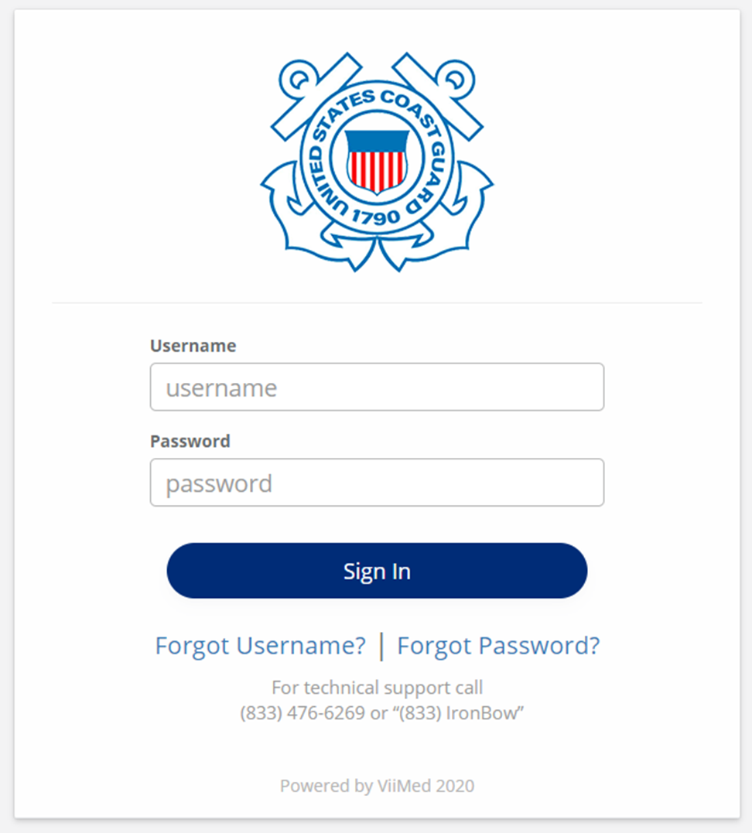

(Image represents Coast Guard Care Anywhere Login Page)

Table of Contents

Contents

1.0 Introduction 3

2.0 How to Access Coast Guard Care Anywhere 4

2.1 Account Activation 4

2.2 CGCA Welcome Screen 4

2.3 Coast Guard Care Anywhere Definitions 5

3.0 Training Video Listing 6

3.1 CGCA training video – Overview 6

3.2 CGCA topic videos 6

a) Accessing Coast Guard Care Anywhere 6

b) Account Activation 6

c) Coast Guard Care Anywhere Definitions 6

d) Create and Manage Schedule 6

e) Logging into Coast Guard Care Anywhere 6

f) Managing Appointments 6

g) Manual Patient Enrollment 6

h) Patient Requests 6

i) Reviewing Visit Requests 6

j) Schedule a Video Visit 6

k) Secure Messaging 6

l) The Daily Routine 6

m) Unscheduled Video Visits 6

# Introduction

The Coast Guard provides primary medical, operational medicine, preventive health, and behavioral health support to the more than 42,000 active duty and 8,000 reserve members across 42 clinics and 160 sickbays. Access to health care has been a continued challenge for the Coast Guard due to the ongoing and projected decrease in PHS providers. During the COVID-19 pandemic, the system has been further stressed by an increased need for medical readiness services and implementation of new measures to safeguard the health of users. To address these long-standing and novel challenges, the Health Services program is moving forward with a rapid deployment of a Telehealth solution.

Telehealth is a remote delivery tool that allows health care professionals care for their beneficiaries, facilitating a wide range of services without actual in-person visits between the health care provider and the patient. Telehealth expands access to care and improves the patient experience by reducing travel burdens on the members. It also protects the users and providers during a pandemic event that requires social distancing. Other benefits of Telehealth include:

• Broader outreach of specialized services by providers including mental health.

• Maximizes use of provider staff to support more remote areas.

• Aids providers in doing more with limited resources.

• Reduces the overall cost of care by providing greater access to CG resources.

• Improves patient accessibility to care.

• Provides less exposure to illness for patients and providers.

• Increases patient options in seeking care.

• Enhances provider flexibility to facilitate a healthy work life balance.

• Improves member readiness, especially in remote locations.

• Enables patients to manage health conditions at home, reducing hospital admissions.

• Allows patients to stay where they are, leveraging their personal support network.

**The primary goals of the telehealth system are to provide:**

• A HIPAA compliant video conferencing system that meets Department of Defense (DOD) and federal cybersecurity standards to supplement face-to-face patient meetings.

• The ability to use mobile devices such as tablets and mobile phones.

• A scheduling of patient appointments based on health care provider availability.

# How to Access Coast Guard Care Anywhere

Where do I go to access this Coast Guard Care Anywhere (CGCA) application? USCG has branded this application as the following:

<https://coastguardcareanywhere.net>

This will redirect you to: <https://virtualhealth.viinetwork.net> (the vendor application)

This service is hosted on the AWS GovCloud.

## 2.1 Account Activation

Users will receive an email and or text notification to activate their Coast Guard Care Anywhere account, this can be completed by following the instructions provided on the activation notice.

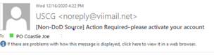

## 2.2 CGCA Welcome Screen

Once account is activated after following activation email, you will be directed to the CGCA welcome screen.

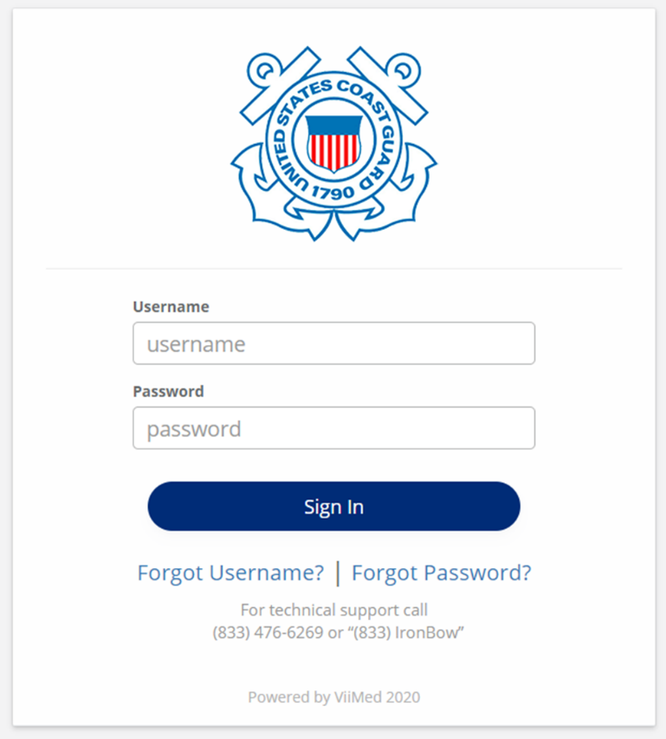

## 2.3 Coast Guard Care Anywhere Definitions

|  |  |
| --- | --- |
| Term | Definition |
| Organization | An entity within the platform that is made up of patients, providers, resource groups, and pathways. |
| Pathway | A virtual care workflow and experience for patients and providers. |
| Activity | A patient or provider facing task, e.g., education, assessment, asynchronous video visit, etc. |
| Registered Patient | A person that has a platform account with a username and password and role of Patient. |
| Registered Provider | A person that has an account with a username and password and a role of Provider. |
| Pathway Assignment | A Registered Patient that is enrolled into one or more Pathways. |
| Resource Group | One or more Registered Providers formed to play specific roles within a Pathway. |
| Resource Type | The specific roles within a Pathway, e.g., Care Coordinator, Behavioral Health Specialist, Physician, etc. |
| Pathway Activity | An Activity that is assigned by the workflow. |
| Provider Activity | An Activity that can be used at any time and used more than once by a Registered Provider. |
| Patient Activity | An Activity that can be used at any time and used more than once by a Registered Patient. |
| Priority Level | A triage process that weights the Registered Patient’s Pathway Assignment. |

# 3.0 Training Video Listing

**(Copy URL into Internet Browser window to access Videos if below links fail, Needs access to Portal)**

## 3.1 CGCA training video – Overview

**The Overview is the first video you should start with as it provides insight to the entire system**

https://cglink.uscg.mil/b0f042f7

## 3.2 CGCA topic videos

**Topic videos are meant as refresher courses to re-inforce what was presented in the Overview Video.**

### Accessing Coast Guard Care Anywhere

<https://cglink.uscg.mil/3681a542>

### Account Activation

<https://cglink.uscg.mil/b29a7105>

### Coast Guard Care Anywhere Definitions

<https://cglink.uscg.mil/bb3013ae>

### Create and Manage Schedule

<https://cglink.uscg.mil/f21cba7e>

### Logging into Coast Guard Care Anywhere

<https://cglink.uscg.mil/18dbd09d>

### Managing Appointments

<https://cglink.uscg.mil/d621822a>

### Manual Patient Enrollment

<https://cglink.uscg.mil/bb2b07ed>

### Patient Requests

<https://cglink.uscg.mil/1858721>

### Reviewing Visit Requests

<https://cglink.uscg.mil/46cf1a79>

### Schedule a Video Visit

<https://cglink.uscg.mil/6984c4e4>

### Secure Messaging

<https://cglink.uscg.mil/e1aefac5>

### The Daily Routine

<https://cglink.uscg.mil/db4702f6>

### Unscheduled Video Visits

<https://cglink.uscg.mil/a51e50ad>